

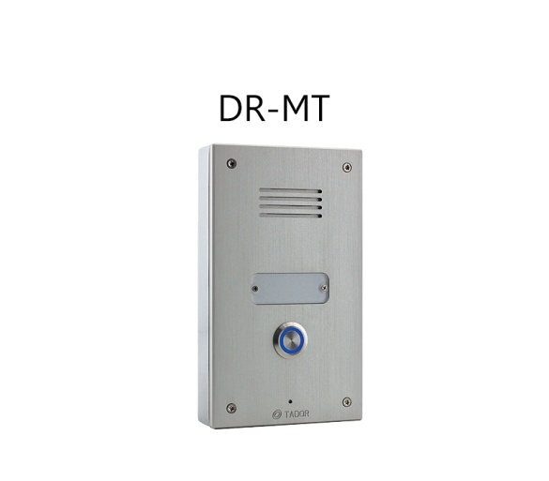**Panel Models :**

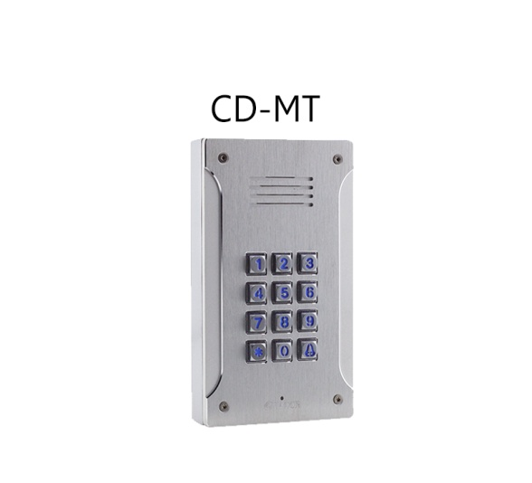

**Hardware:**

* Operating voltage: 12V Voltage Transformer rates at least 1000mA.
* Electric lock / magnetic lock.
* 40 access control codes
* Normally Open or Normally Close.
* Keypad / Button.
* Illuminated.
* Dial extension.
* Connect to Analog PBX
* Aluminum IP 65.
* Echo cancellation
* Unlimited panels per installation ( each need different IP Address / Extension )
* IK07

Surface or Flush Mount :

|  |  |
| --- | --- |
| * Surface Mount | * Flush Mount |
| Depth – 30 mm | Depth – 30 mm |
| Length – 171 mm | Length – 190 mm |
| Width – 99 mm | Width – 102 mm |

**Optional:**   
- 2 and 4 calling buttons.  
- Keypad Panel: allow enter by access code  
- Rfid Access control

**Functions:**- Full Duplex   
- Register as extension of analog PBX